1. **Create a new Spring Boot project:**

• Use Spring Initializer or your preferred IDE to create a new Spring Boot project.

• Add a simple REST endpoint to the application.

Commit and Push:

• Initialize a Git repository in your project folder.

• Commit the initial code and push it to a remote repository

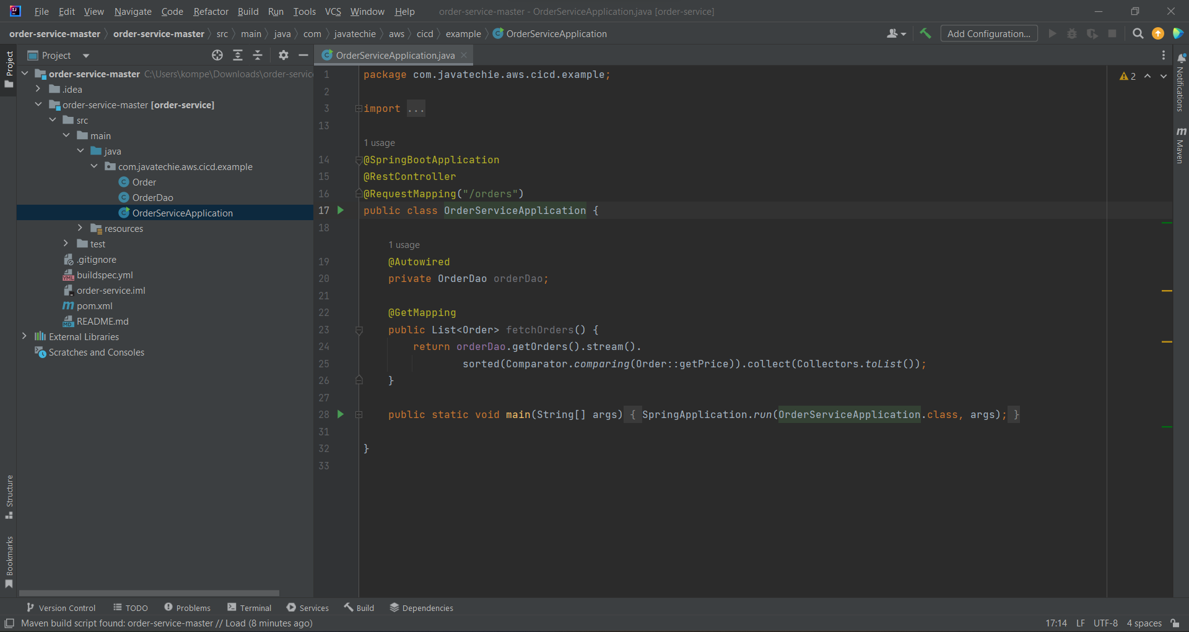

1. **Create a ci pipeline:**

• Open Aws console and go to Elastic Beanstalk.

• Create a new environment in EBS.

• Open Aws console and go to Code Pipeline.

• Create a pipeline.

• Add source provider as Github and specify the repo.

• Add build provider as Aws Codebuild.

• Create a Project in code pipeline and add buildspec file there.

• Deploy the code using Elastic Beanstalk.

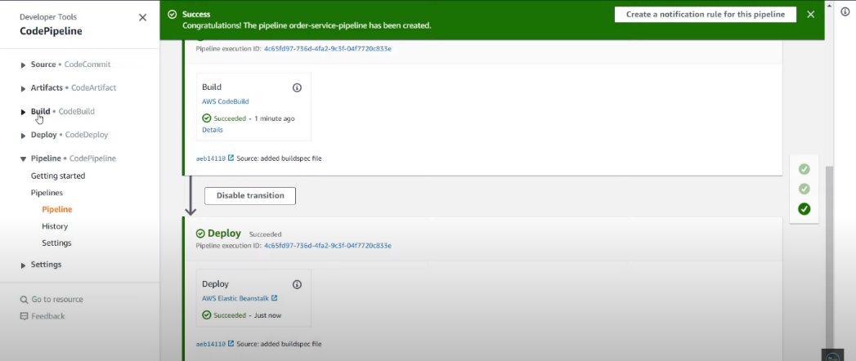

**Logs:**

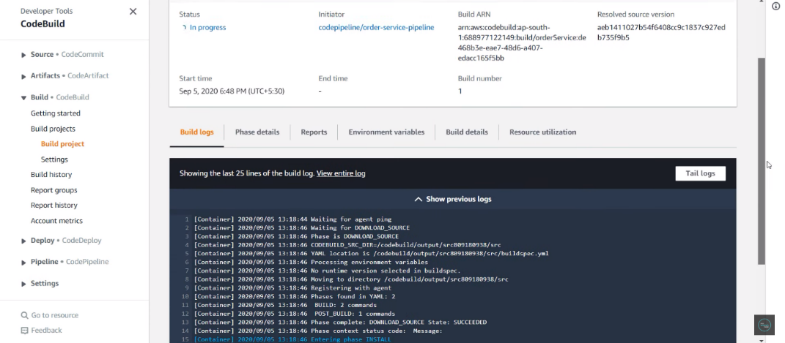

**Final Output:**

